Pack the Flat-Matic as shown below
Step 1
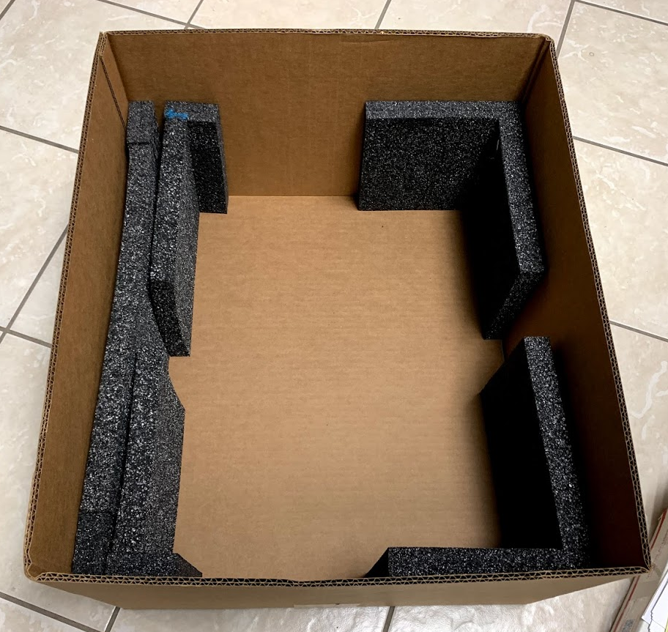
Step 2
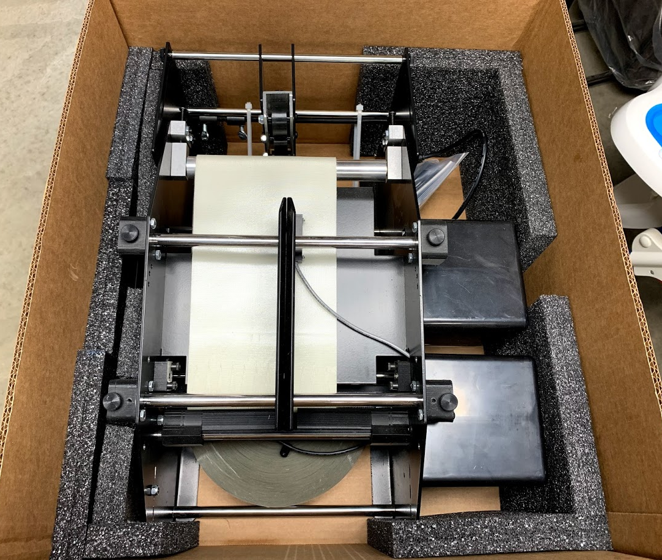

We also will Facetime with you to insure you are properly packing a machine for transport.
Step 3
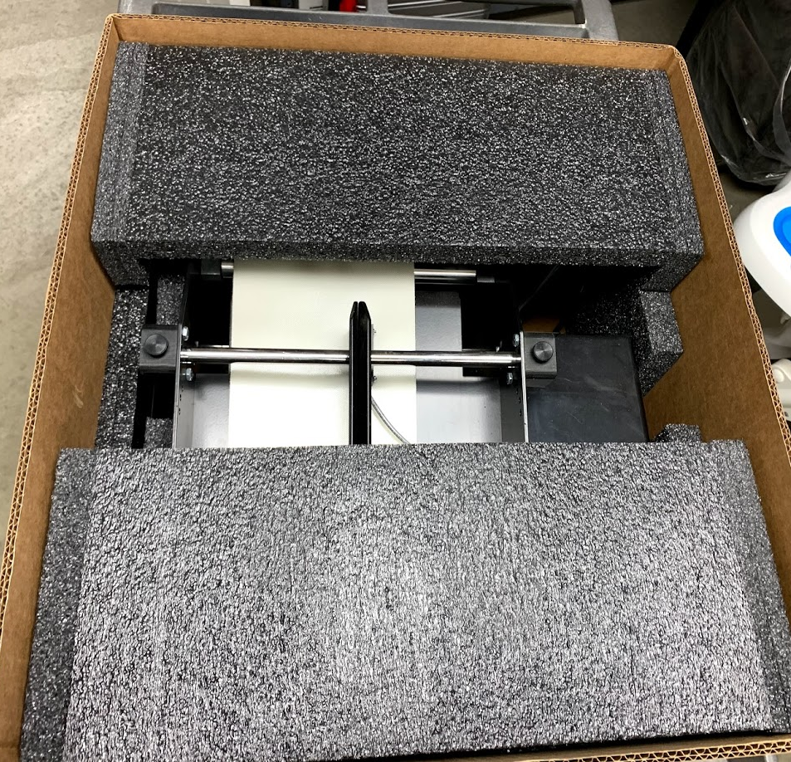
Step 4
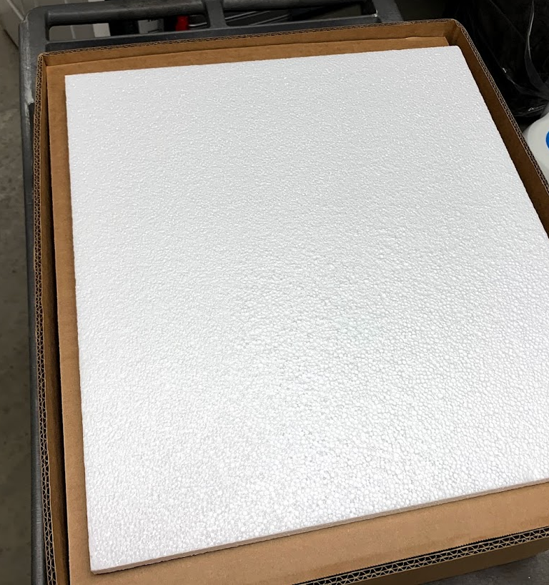

Pro Pack Solutions, Inc., 2421 Lance Court #B, Loganville, GA 30052
Ph 770-554-1187

